***Machine Learning Vs Deep Learning***

***1.Data Dependency***

*Deep Learning Needs lot of data comparision to Machine Learning.*

*Less Data ML Beats DL ML > DL*

*More Data DL Beats ML DL > ML*

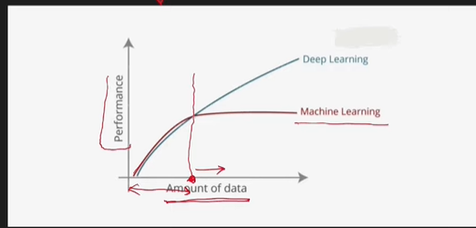

***2.Hardware Dependency***

*DL needs costly hardware for GPU & even Memory*

*ML can be done in CPU also*

***3.Training Time***

***DL takes a lot of time to train***

***DL training time is very High***

***Lyk even For Research work months tak lageh hai Model train hone mai***

***Whereass in ML it takes some minutes to train.***

***4.) Feature Selection***

*In DL automatically it extracts relevant features*

*In ML we have to extract features manually.*

*In DL*

*Start mai Low Level Features Extract krrhe then*

*Mid Level Features extract krrhe*

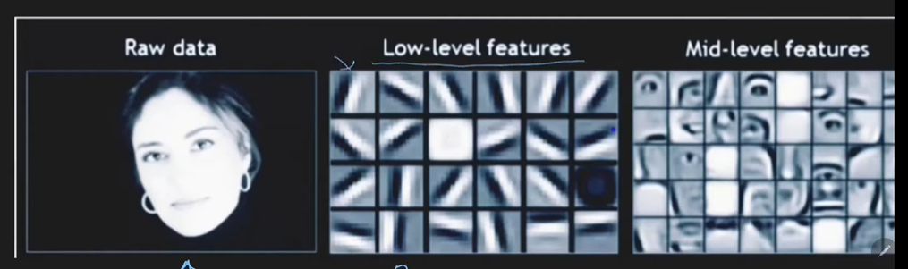

***5.) Interpretability***

***As we know features are extracted automatically,***

***But what this features are how to interpret that ? ki vo feature hai kya ?e.g: dog hai ki cat etc .***

***DL yeah kaam automatically krdega***

***But yeah Interpretability jo hai***

***Deep Learning andar kaise interpret krrha yeah Pura Black Box hai***

***But humme kabhi smjhega ya pata nahi chalega ki***

***Interpret kaise krrha hai Algorithm***

***This is Big Flaw of Deep Learning .***

***Deep Learning fail krta hai yaha***

***Whereass Machine Learning interpretability batata hai Very highly ki kaise vo Answer deraha ki output yeah hai .***

***Deep Learning pura Black Box hai .***

***Conclusion:***

*In some scenario ML is better than DL*

*DL can’t replace ML fully.*